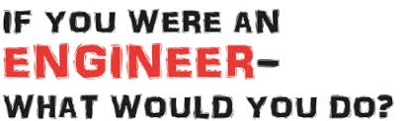

Primary Engineers Award!

We are delighted to celebrate the work of all of our budding engineers who entered the Primary Engineers Leaders Award earlier this year. Three of our pupil’s inventions have been awarded a distinction and will be displayed in the public gallery at Sunderland University on Saturday 8th June.

How amazing is that!!

