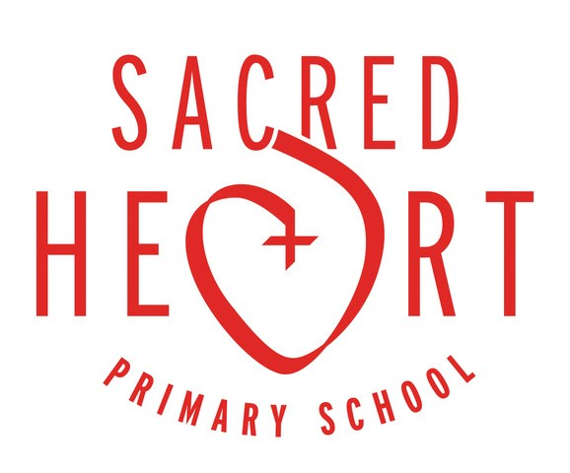

During Advent we will be joining forces with Sacred Heart schools around the World to raise money for two projects in the Philippines. The St Madeleine Sophie Foundation,(SMSF), which has been devastated by 2 recent typhoons Rolly and Ulysses. I

This is a quote from someone who is part of the SMSF
“What is SMSF for you?” She answered, “SMSF is a bridge for the poor people to have a new hope in life. At SMSF, I don't feel that I'm just one of many; rather, I feel loved as a member of a family.”

The text below is from the JPIC facebook page.
The Philippines which is still reeling from the last typhoon (Rolly), is hit by yet another one(Ulysses). International media will show more photos, but here we share a few that were taken by those closest to us. The first 3 were taken were taken by mothers connected to St Madeleine Sophie Foundation(SMSF) in Montalban. Their houses are close to our community/property, which experienced flooding due to the swelling of Montalban River (pic with green roof). The situation is even worse in many places, especially those that were hit by Rolly last week. The cry of the poor and the cry of our Common Home are deeply intertwined.

We will also be raising money for the Sacred Heart Institute for transformative education foundation. (SHIFT), In Mondragon in the Philippines.
They need support with Early childcare education, community leadership and humanitarian assistance.
- Each class bubble will be planning their own sponsored event that will take place in school at the beginning of December.
- We will update you on what each class will be doing and post pictures on the class blogs.
- Please pay money towards sponsorship of your Children on our school Just Giving page.
- Please ensure that all sponsor money is paid by the 10th December 2020.

Many thanks,
Mrs Hall and the Mini Vinnies

