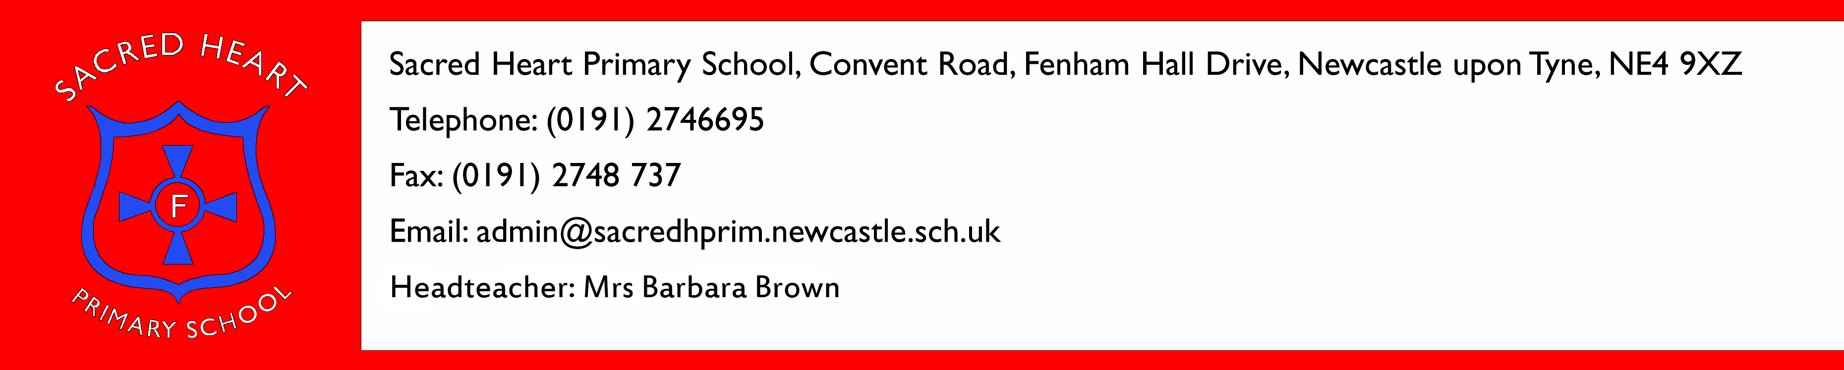

Dear Candidate,
Sacred Heart Schools International Network

Thank you for showing an interest in the position of Support Assistant in our school. Included in the application pack are:-

- Job description
- Personal specification
- Application form
- Safe recruitment form

Please complete the application and safe recruitment forms and return paper copies to school at the above address, along with a stamped addressed envelope, by noon on the 9th October.

Visits to the school are warmly welcome by appointment. Please contact the school office to arrange.

Yours sincerely

Mrs B Brown
Headteacher

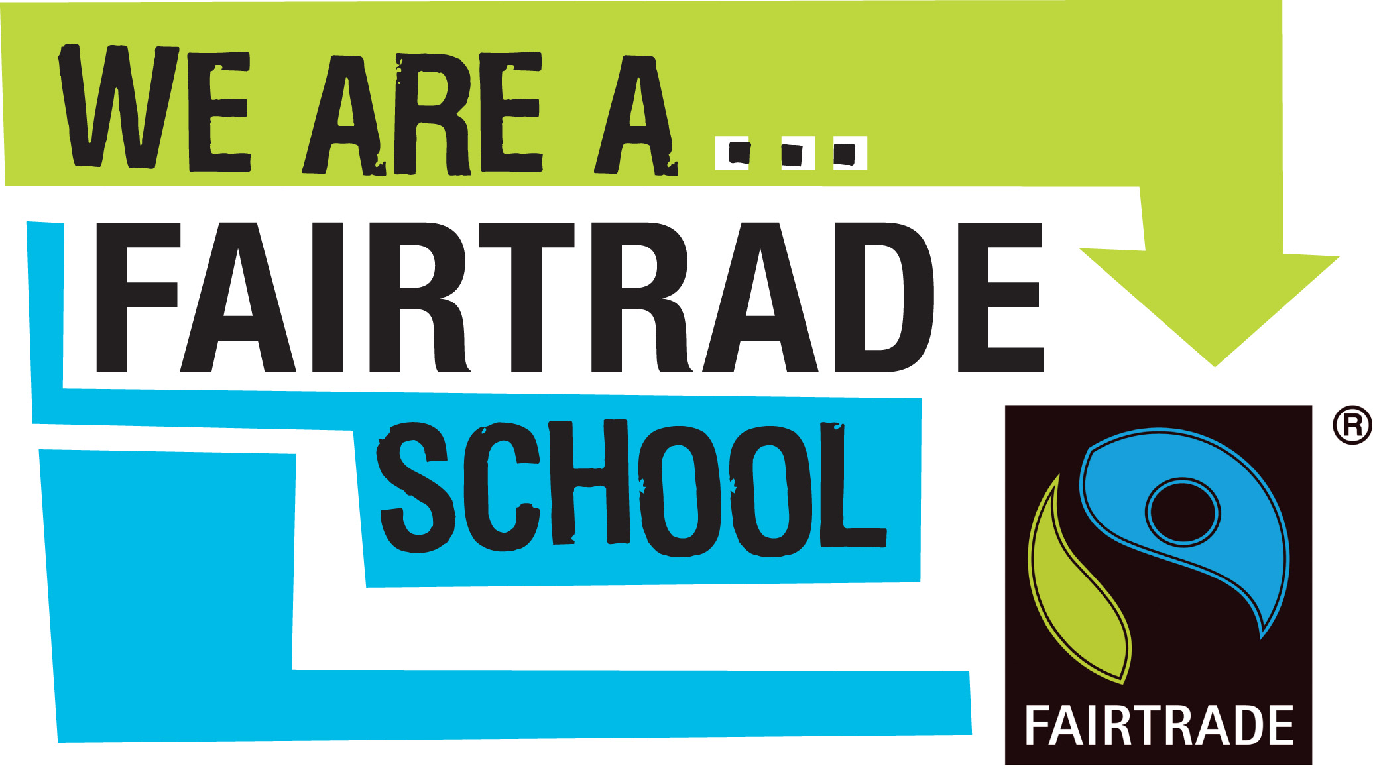
Sacred Heart Schools International Network

