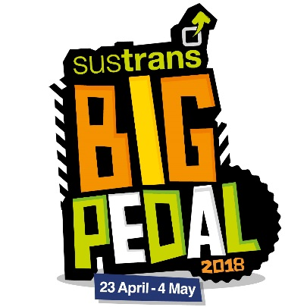
Dear Parents/Carers,

Get set… we’re taking part in Sustrans Big Pedal 2018, the UK’s largest inter-school cycling and scooting challenge that inspires pupils, staff and parents to choose two wheels for their journey to school.

The challenge runs from 23rd April to 4th May. It’s free to enter and we would love everyone to be involved.

The details
On each day of the challenge schools compete to see who can record the greatest number of pupils, staff and parents cycling or scooting to school. Our best day will determine our final position in the challenge. We’ll be competing against other schools right across the UK, and if we clock up the most bike and scooter journeys we’ll win!

Why we’re taking part
It’s a great way to get more of our pupils travelling to school on their bikes and scooters. We will be competing to become one of the UK’s top schools for two-wheeled journeys and will be in with a chance to win prizes including bike and scooter stunt shows and fantastic cycle and scooter storage.

Cycle, scoot and snap to win family prizes
You and your family can also win prizes during Sustrans Big Pedal. Simply post a photo of you and your child cycling or scooting to school on social media during the challenge using #BigPedalWin. To be in with a chance of winning follow Sustrans on Instagram instagram.com/sustrans, Twitter twitter.com/sustrans or Facebook facebook.com/Sustrans. Be sure to check the terms and conditions found on the Big Pedal website prior to entering the competition.

What’s next?
All you need to do is encourage your child(ren) to cycle or scoot to school on Monday 23rd April, and join them on their way – parent and sibling journeys count too!

For more information about the event go to www.bigpedal.org.uk

Follow Sustrans on social media (instagram.com/sustrans, twitter.com/sustrans facebook.com/Sustrans
Enjoy the ride!
Mrs Brown

