|  |  |
| --- | --- |
| **Key Vocabulary** | **EARLY YEARS**  **Good News**  **PENTECOST – SERVING**  For Christians, the Gospel is the Good News of God’s love for everyone. At Pentecost, in the gift of the Holy Spirit given for all, Christ’s mission of bringing the Good News was entrusted to the community of believers which is the Church.  Children will know and understand:  • That everyone has Good News to share  • Pentecost: the celebration of the Good News of Jesus  **See the Background Notes for Parents**  **Week 1**: Share some good news stories. Read *the Jolly Postman by Janet and Alan Ahlberg -* available on Youtube <https://www.youtube.com/watch?v=gpeo_0yoD0k>  **Week 2**:Remind children of the Good News of Easter and tell the Pentecost story. Children can make windmills (see template) or Alleluia banners.  **Week 3**:Talk about how the Church celebrates Pentecost, the birthday of the Church. Decorate balloon or cake templates.  **Week 4**: Celebrate what you have learnt with a simple liturgy <https://missiontogether.org.uk/pentecost/>  <https://cafod.org.uk/Education/Primary-teaching-resources/Pentecost-primary-resources> |
| good news  share  Good News  Pentecost  Promise  Holy Spirit  Easter  alleluia, |

Week 1 **A Story to tell**

Mummy, Mummy!” I shouted. I ran across the playground as fast as I could. I wanted to tell her my good news. Mummy was standing at the school gate talking to Mrs Brown. I got to her out of breath and all hot and bothered.

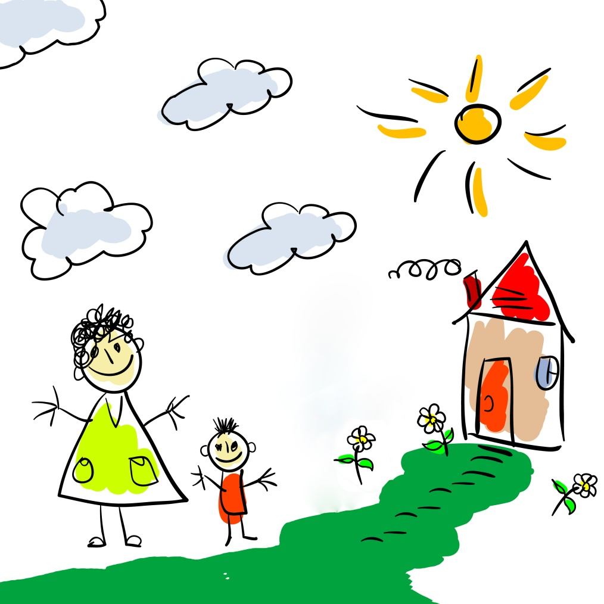

“Mummy, Mummy!” I said, excitedly. “I painted a lovely picture,” I told her. “It was you and me going shopping. Mrs White said she’ll put it on the wall for everyone to see!”

“That is good news,” said Mummy. “Well done, Darren.”

Week 2 Easter Sunday

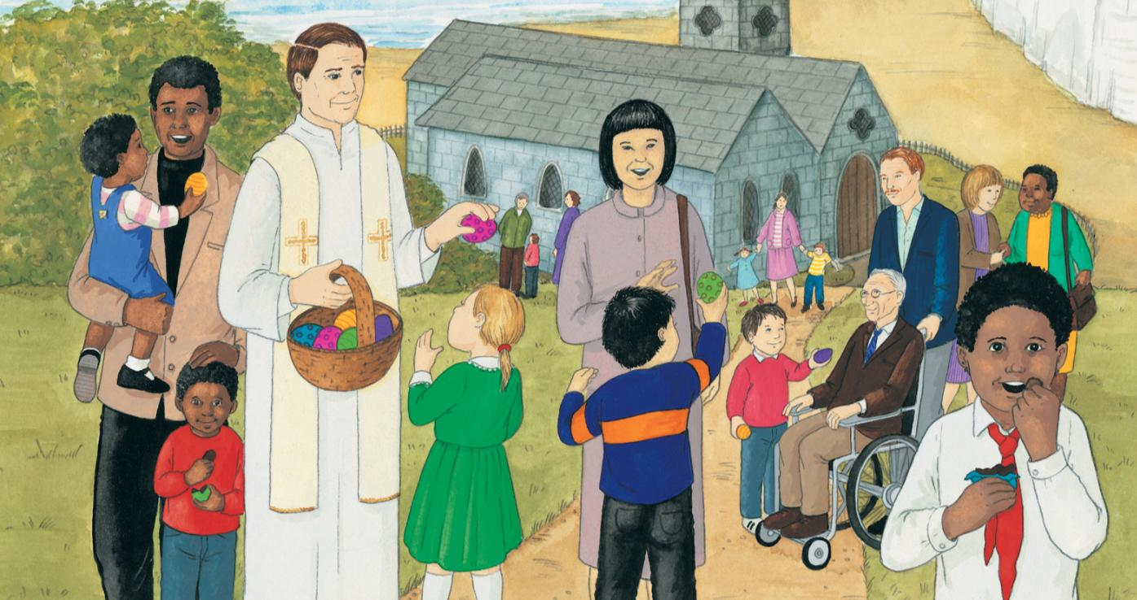

**Here is an Easter egg to colour in.**



The Good News of Easter is that Jesus has risen from the dead.

Alleluia is the Church’s special Easter word meaning ‘Praise God!’

Alleluia! We are happy.

It is Easter Sunday. Jesus is alive.

Week 2 Pentecost

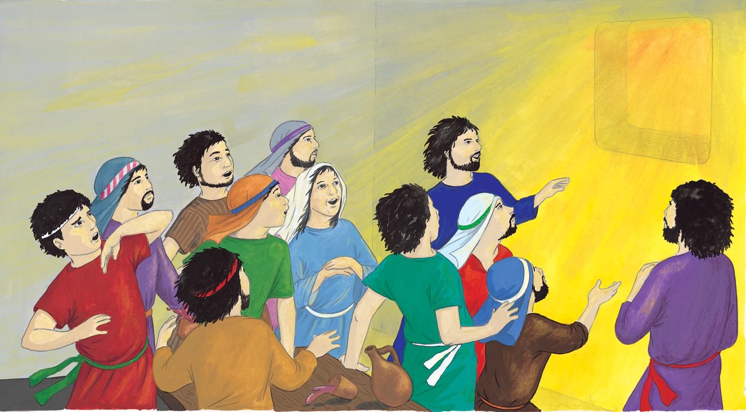

They knew that Jesus had kept his promise to send a new friend, the Holy Spirit.

What do you see?

What do you think is happening?

How do the people feel?



**Week 3 Balloon Template**



**Week 3 Cake Template**