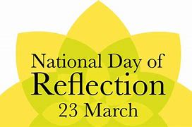

Dear Families,
Today marks exactly one year since the start of the first national lockdown due to COVID 19. It is marked by a National Day of Reflection, a day that is meant to let people pause, to come together to reflect on a collective loss, support those who have been bereaved, and hope for a brighter future.
There are still tough times ahead and we urge everyone to consider how we can all continue to pull together to get through this. Sadly in school, we have had a new case of covid confirmed just today, this pandemic is NOT over.
I ask you all to follow the rules and all the guidance given to you. (No trips to the hairdressers, or friends houses for tea). By doing this everyone can be confident that we are all doing absolutely everything possible to reduce transmission of the virus. We must not get complacent.
We are taking a super cautious approach in school to anyone with symptoms.
It is urgent that you do not send your child to school if they have any symptoms of covid at all. You should access a PCR Covid test and share the negative result with us before they can return to school.
The main Covid symptoms are:
- a high temperature,
- a new, continuous cough, or
- a loss or change to sense of smell or taste;
Do not send your child to school if they live with someone who has symptoms of Covid-19 or has tested positive for Covid-19 including brothers, sisters, parents.
Even if you think that your child JUST has a cough because they have cold, or JUST has a slight temperature because they have a sore throat. You should take them for a Covid PCR test straight away.
We will not accept the results of Lateral Flow tests as proof of a negative test if any of the above symptoms are displayed.
Thank you in advance for your understanding and patience during this very difficult time, let us remember those whose have lost loved ones and support each other through the coming weeks and months.
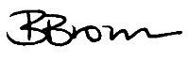
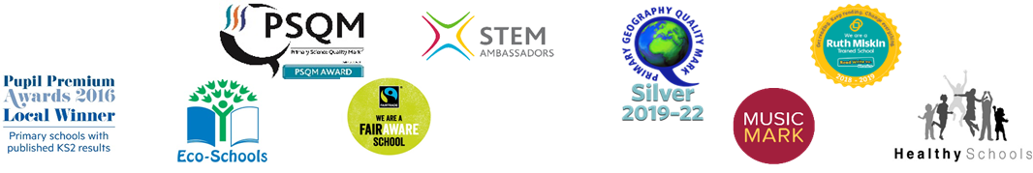
Yours sincerely,

