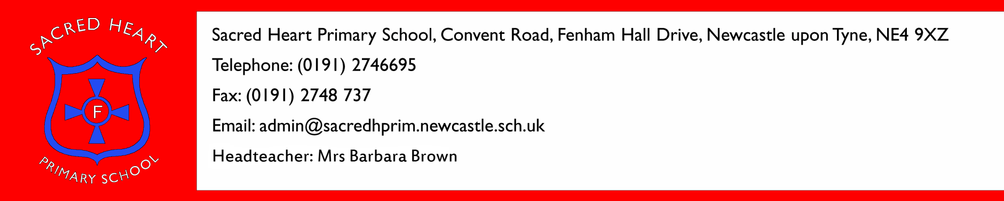

5th November 2015

Dear Parents/Carers

I am writing to let you know of the outcome of the Parent Governor election. We received two nominations for the two Parent Governor places and therefore there was no need to hold a ballot.

The new Parent Governors are:

Hayley Douglass
Sarah Peel

I wish to thank everyone who attended the open sessions for Parent Governors and especially the candidates for showing their commitment to the school.

Kind Regards
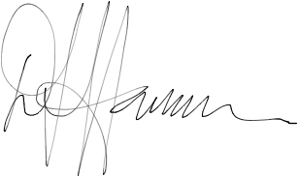
David Harrison
Chair of Governors

Sacred Heart Schools International Network
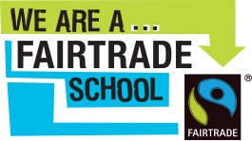
Sacred Heart Schools International Network
