Key Vocabulary | YEAR 1  Holidays and Holy Days  PENTECOST – SERVING  For Christians, Sunday is the special day of the week. It is the day on which Jesus rose from the dead and is considered to be a day of rest. Pentecost is a special celebration of the gift of the Holy Spirit, through whom the risen life of Jesus is given.  Children will know and understand:  • Holidays as days to be happy  • Pentecost; a holy day – the feast of the Holy Spirit  See the Background Notes for Parents  Week 1: Talk about holidays you have enjoyed at home or away. Children can draw a picture of holiday activities – going to the park, playing out, travelling.  Week 2: Share the story of the Ascension of Jesus. What promise did Jesus make to his friends? Fill in the speech bubble on the template below.  Week 3: Share the story of Pentecost. How were the disciples changed by the coming of the Holy Spirit? Draw their faces before and after Pentecost on the template below.  Week 4: Celebrate what you have learnt with a simple liturgy https://missiontogether.org.uk/pentecost/  https://cafod.org.uk/Education/Primary-teaching-resources/Pentecost-primary-resources
Holiday
Holyday
Apostles
help
Pentecost
promise
Holy Spirit
guide
Resurrection
alleluia

Week 2 On Ascension Day Jesus went back to his Father in Heaven. He promised to send the Holy Spirit.

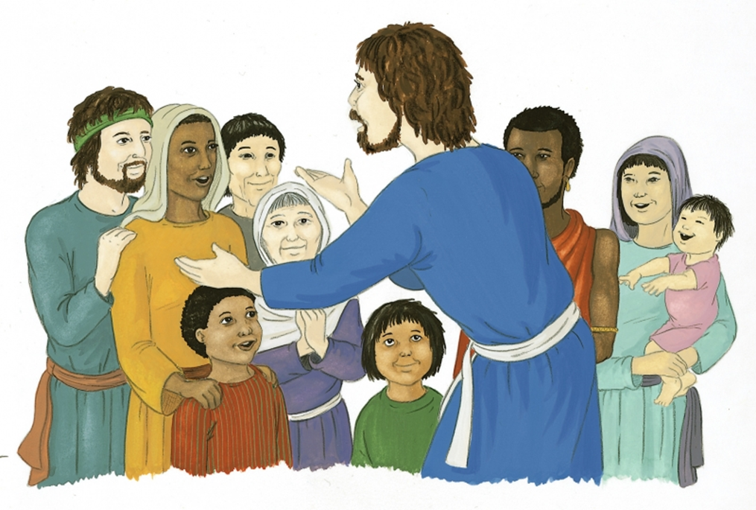
Week 3

Before the coming of the Holy Spirit After the coming of the Holy Spirit

