

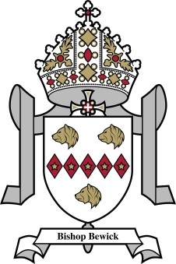

Bishop Bewick Catholic Education Trust
Assistant Caretaker - to begin April 2022
POST TITLE: | Assistant Caretaker - Permanent
PAYSCALE: | N3 £18,562 – £18,933  This is a full time role, 37 hours per week Monday to Friday over 52 weeks, 24 days paid holiday + Bank Holidays
RESPONSIBLE TO: | Site Manager
The Bishop Bewick Catholic Education Trust wishes to employ an enthusiastic individual as Assistant Caretaker to work across different sites within the Trust, predominantly Sacred Heart Primary School and Sacred Heart High School both located Convent Road, Fenham, Newcastle

The successful candidate will work across several sites to support and assist the site management team. Overall Role:
- To undertake general caretaking and cleaning duties as directed by the facilities manager.
- Repairs and maintenance of all school buildings and premises, ensuring they are maintained to the highest standards.
- Ensuring the safety and security of the school site(s).
- Ensuring that the school grounds are maintained to the highest standards.
Any other duties within reason that contribute to the efficient running of the school premises - for more information please see the full job description.

About you
It is essential that the postholder:
- Has the practical ability to problem solve and use initiative
- Is able to organise, prioritise and complete tasks efficiently
- Has the ability to work effectively with people from a wide range of levels and responsibilies
- Work as a team member
- Has oral and written communication skills adequate to the role
- Is able to accept instruction and seek clarification where necessary
- Is physically able to carry out porterage duties, which will involve lifting, and is able to work at height
- Has the ability to understand and follow instructions on equipment, materials, etc
- Is able to liase with external contractors when working on site
- Has the ability to perform minor repairs and has experience in using hand tools

In all aspects of the post the candidiate must implement faithfully and effectively the Aims and Policies of this Roman Catholic Education Trust and work collaboratively to ensure that the Christian ethos, standards of academic excellence and good behaviour are maintained and strengthened.

Application packs are available on the school website at: www.bishopbewick.org

Closing date: 9.00am on Monday 28th March 2022.

The governing body and the Diocese are committed to safeguarding and promoting the welfare of children and young persons. The successful candidate will be required to undergo an Enhanced Disclosure from the Disclosure and Barring Service (DBS).

