Puberty resouces to support parents and carers

‘So God created human beings in his own image, in the image of God he created them; male and female he created them’ Genesis 1:27
Within our schools in the Diocese of Hexham and Newcastle, we want each and every pupil to know that they are created in the image and likeness of God and that our physical bodies are a reflection of that belief. Our Relationships and Health Education includes lessons enabling pupils to understand that the changes which occur during puberty are natural and God given, as our young people grow towards maturity and the possibility of parenthood.
These lessons in school cover the emotional and physical changes that take place as young people grow up. Often the school nurse will support the school staff to reinforce the practical learning about the changes which occur during puberty and allow the children to ask any questions in a safe and confidential way. Children have the right to know how their bodies change and the emotional impact of puberty so they are prepared before starting to go through these changes.
Older primary school children within the diocese (usually years 5 and 6) may well have received these lessons earlier in the academic year. However, a lot of schools build these lessons into transition work, preparing children for the move to the next class or next school and therefore teach about puberty within the summer term. In the light of COVID 19 and the temporary closure of schools, your child may miss out on this important discussion in their classrooms.
As parents, you will appreciate the importance of talking about the onset of puberty with your child and one positive to being in lockdown is that it gives families the time to have these conversations in the comfort of their own homes at a time and pace that is suitable for them. We also appreciate that many parents may find this awkward, tricky or embarrassing and the following suggestions are offered to support you in this task.

Ideas for parents
- It is best to start long before puberty starts. When your child is young, they are less likely to be embarrassed so encourage them to talk about their bodies.
- Always use the correct terminology when talking about body parts e.g. breasts, vagina, penis and testicles. Knowing the correct words for parts of their body helps to keep children and young people safe and look after their health. Even if you use other words at home, it’s important that children know the correct terms too. This applies to the changes that occur in puberty too (e.g. testosterone, hormones, menstruation) when discussing puberty. It will encourage your child to treat the conversation with maturity.
- One way of assessing your child’s knowledge and feelings is for your child to start by labelling a body with what they know. Encouraging them to ask questions as they do this will give opportunity for discussion and develop understanding about the need for good hygiene and respect for this stage of their lives.
- Contact your child's school, check out their website and try to find as much as you can about what they would be taught in lessons. It is important to check that the children do not have any misconceptions and that you are able to explain anything they have not understood.
“The strength of the family lies in its capacity to love and to teach how to love.”
Pope Francis ‘Amoris Laetitia’

Suggested resources
CAFOD video on Human Dignity: https://www.youtube.com/watch?v=8zhtPDXRthM

Growing Up In God's Image by Carolyn J Smith
https://www.amazon.co.uk/dp/B009B0UAWS/ref=dp-kindle-redirect?_encoding=UTF8&btkr=1

The Care and Keeping of You by Valorie Schaefer
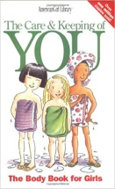 https://www.amazon.co.uk/Care-Keeping-You-Revised-American/dp/1609580834/ref=sr_1_1?dchild=1&keywords=The+Care+and+Keeping+of+You+by+Valorie+Schaefer&qid=1591608245&sr=8-1

All Things Guy: A Guide to Becoming a Man that Matters by Cheryl Dickow (for boys aged 9-14)
https://www.amazon.co.uk/All-Things-Guy-Becoming-Matters/dp/0982122268/ref=sr_1_1?dchild=1&keywords=All+Things+Guy%3A+A+Guide+to+Becoming+a+Man+that+Matters&qid=1591608461&sr=8-1

Susan's Growing Up By Sheila Hollins and Valerie Sinason
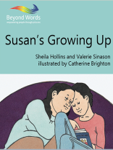 https://booksbeyondwords.co.uk/bookshop/paperbacks/susans-growing
A book on growing up for parents to share with children with learning disabilities

Free PowerPoint from ‘Twinkl’ about menstruation: https://www.twinkl.co.uk/resource/t2-p-218-sex-and-relationships-education-menstruation-powerpoint

Please find attached a selection of worksheets that may be helpful in engaging your child in conversation.
Changes during puberty
Changes | Boy | Girl | Both
Grow taller
Skin becomes oily
Spots appear on skin
Hair grows on face
Hair grows under arms
Hair grows on arms and face
Hair grows on genitals (pubic hair)
Breasts develop
Hips get bigger
Testicles produce sperm
Penis grows longer and wider
Testicles grow larger and fuller
Body produces sex hormones
Ovaries start releasing eggs
Periods start
Produce vaginal discharge
Body shape changes
Weight gain
Face shape changes
Spontaneous erections and wet dreams
Voice becomes deeper
Body sweats more
Sometimes feel lonely and confused
Mood swings (including irritability, tearfulness, overwhelming happiness and confusion)
May become argumentative and bad tempered
Want more independence
Start to think about the future
Start to think more about appearance

Put a cross in the correct column

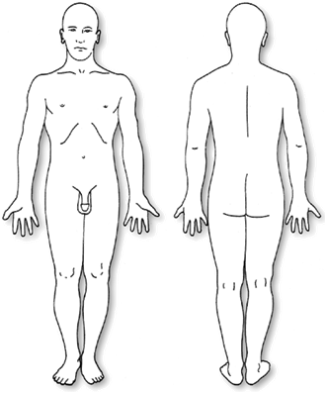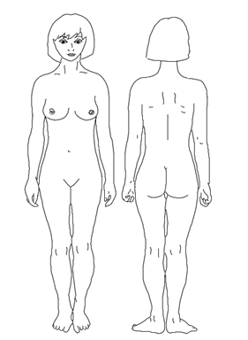
Female
Male
Label as much of the body as you can and write below about the changes which take place in each during puberty.
________________________________________________________________________________________________________________________________________________________________________________________________________________________________________________________________________________________________________________________________________________________________________________________________________________________________________________________________
________________________________________________________________________________________________________________________________________________________________________________________________________________________________________________________________________________________________________________________________________________________________________________________________________________________________________________________________
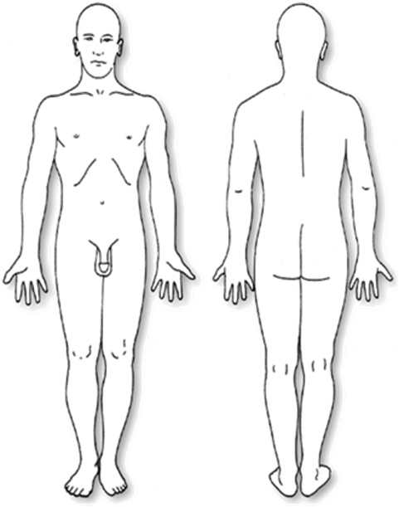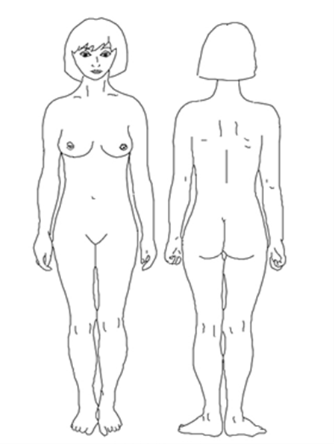
Female
Male

When boys reach puberty their voice ………………………………… When girls reach puberty their breasts …………

They will start to grow ………………… on their faces, around They will start to grow …………… under their

their penis and testicles and under their ………………… A boys’ arms and around their pubic area. Their hips

penis and testicles will ……………………………… They may start to will ……………… They may have ………… and ……………

have ………………………… and their hair may be ……………………… hair. They will start their ………………………
Label as much of the body as you can and complete the sentences.

