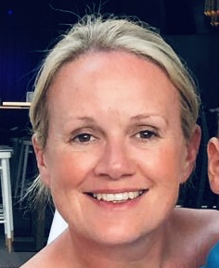

Hello. My name is Mrs Murdy and I will be your Reception teacher in September. I love reading stories and Julia Donaldson stories are my favourite. I am so excited to meet you all and see you all in school.

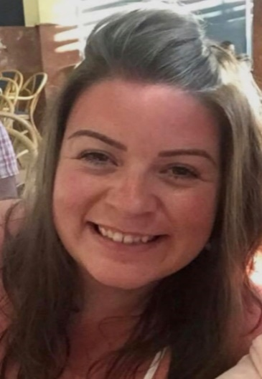
Hello my name is Mrs Bays and I am the Nursery Nurse in Reception class. I enjoy reading stories and going to Forest school. I can’t wait to see you all in September.
taff

