Mini Vinnies work
2022 – 2023

During the Autumn term we focussed on Harvest Day and joined forces with our friends in the Community of St Robert’s parish and their links with Malawi. The Mini Vinnies were involved with a cake sale in St Robert’s hall after Sunday mass on the 16th October 2022. We then added to this with a school coffee and cake afternoon with Mama Cath and Dave to raise money for food and to Raise the Roof on the school in Malawi.

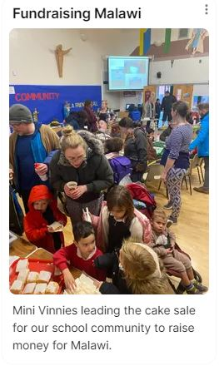
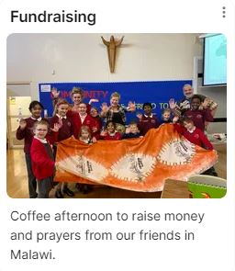

This year we have reignited ‘Canny Friday’ in school. Together we made posters and shared the project with our friends in class. Thank you so much to all our families who
have been so generous.

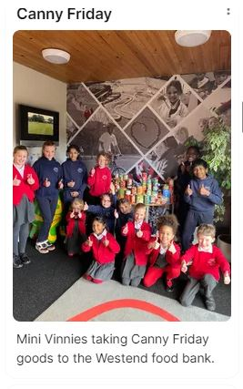
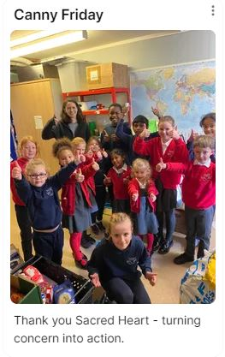

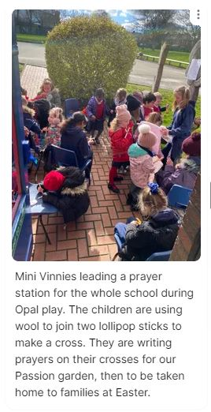
This year we have written letters to the lonely, sent Christmas cards to our Nuns throughout England and our friends in Malawi. During Lent with led a prayer station for the rest of the school during Opal play.

